A Novel Ensemble Machine Learning and an Evolutionary Algorithm in Modeling the COVID-19 Epidemic
Presented by: Mohammad-Hassan Tayarani-Najaran
Research Area:
The research explores the use of ensemble machine learning models and evolutionary algorithms to analyze and predict the spread of COVID-19. The study utilizes data-driven methodologies to understand the effects of various government policies on controlling the pandemic. By leveraging multiple machine learning models, including support vector machines (SVMs) and neural networks, the study aims to improve prediction accuracy. Additionally, a population-based multi-objective optimization algorithm is employed to balance the trade-offs between minimizing infection rates and mitigating economic impacts. The integration of ensemble learning and evolutionary algorithms offers a robust approach to managing pandemic-related uncertainties (Tayarani-Najaran, 2022). This research is significant due to its potential to inform policy decisions and optimize public health strategies effectively.
Recent studies have emphasized the role of AI-driven predictive models in improving pandemic response (Arora et al., 2021). Moreover, real-time epidemiological simulations using computational techniques have become crucial in assessing intervention efficacy (Prem et al., 2020).
Relation to Computer Science in General:
This research is interdisciplinary and relates to several fields within Computer Science, including Artificial Intelligence (AI), Data Science, and Optimization. Machine learning techniques, particularly ensemble learning, play a crucial role in predictive analytics, helping model pandemic trends. Additionally, evolutionary algorithms contribute to operations research and optimization, ensuring the best policy decisions with minimal societal costs. The study also intersects with computational epidemiology, leveraging AI-driven models to simulate virus transmission dynamics. Beyond Computer Science, this research is relevant to Public Health Informatics and Economics, demonstrating how computational methods can enhance real-world decision-making processes (Sözen et al., 2022; Mohamadou et al., 2020; Wang et al., 2020).
Additionally, the use of big data analytics is reshaping how governments assess mobility patterns and policy effectiveness (Engle et al., 2020). The rise of explainable AI (XAI) is also crucial for making these models interpretable for policymakers (Molnar, 2019).
Research Questions and Methods:
A key research question in this area is: "How can ensemble machine learning and evolutionary algorithms be effectively combined to predict and optimize pandemic response policies?" To address this, the study employs a hybrid methodology:
- Data Collection: Using publicly available datasets on COVID-19 cases and government responses.
- Machine Learning Models: Ensemble techniques integrating neural networks, SVMs, and K-Nearest Neighbors (KNN) to enhance predictive accuracy.
- Optimization Approach: A multi-objective evolutionary algorithm to determine optimal policy interventions.
- Validation: Comparative analysis of predictive performance using mean squared error and model robustness testing.
The application of deep learning architectures such as convolutional neural networks (CNNs) has also been explored to improve forecasting accuracy (Al-Qaness et al., 2020). Moreover, reinforcement learning approaches have shown promise in adaptive pandemic decision-making (Padmanabhan et al., 2021).
General Relevance:
The significance of this research extends beyond pandemic modeling. Machine learning-driven predictive analytics have broad applications in public health, urban planning, and emergency response management. By improving forecasting capabilities, governments can proactively implement targeted interventions, reducing the impact of crises. Additionally, the integration of optimization algorithms ensures cost-effective decision-making, balancing health outcomes with economic stability. However, the research also raises ethical concerns, including data privacy issues and the potential for algorithmic bias in decision-making. Ensuring transparency in data collection and model interpretability is crucial for maintaining public trust. Future advancements could refine these models to incorporate real-time data streams, further enhancing the accuracy and responsiveness of AI-driven policy recommendations (Sözen et al., 2022; Flaxman et al., 2020).
The development of federated learning techniques may mitigate privacy concerns while enabling collaborative pandemic research (Yang et al., 2019). Moreover, blockchain-based health data systems have been proposed to enhance data integrity and security in AI-driven epidemiological studies (Sharma et al., 2021).
Visualizations:
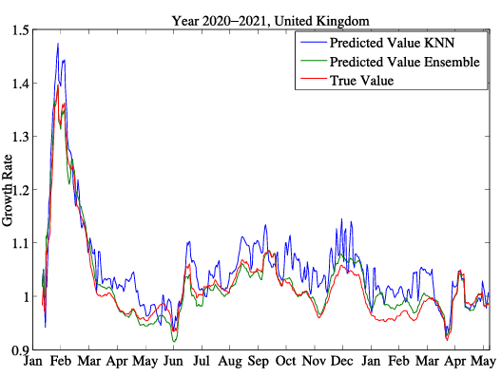
Fig (1). Predicted and true values of growth rate of the number of cases in the U.K. using KNN and the proposed ensemble algorithm. These data are generated by using all the data except the data for the U.K. to train the models. Then, the model is tested on the U.K. data.
  - This figure illustrates the comparison between the predicted and actual number of COVID-19 cases over a defined period. It highlights the accuracy of the ensemble learning model in forecasting pandemic trends, showing how different machine learning models contribute to an improved predictive performance.
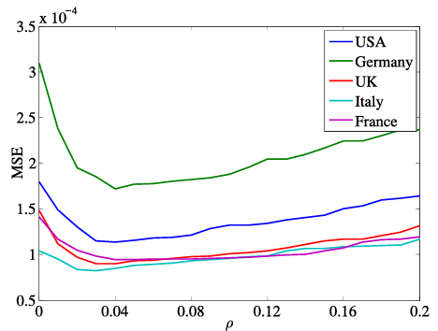
Fig (2): Performance of the proposed ensemble learning algorithm when the averaging operator is used for different values of radius. This is averaged over all the data records for each country.
  - This figure demonstrates the results of the multi-objective optimization algorithm. It presents a Pareto front where policymakers can assess the balance between economic cost and pandemic containment measures. The visualization helps illustrate how different policies impact both infection rates and economic consequences, allowing for more informed decision-making.
References:
- Tayarani-Najaran, M.-H. (2022). A Novel Ensemble Machine Learning and an Evolutionary Algorithm in Modeling the COVID-19 Epidemic and Optimizing Government Policies. IEEE Transactions on Systems, Man, and Cybernetics: Systems, 52(10), 6362–6368.
- Sözen, M. E., Sarıyer, G., & Ataman, M. G. (2022). Big data analytics and COVID-19: Investigating the relationship between government policies and cases in Poland, Turkey, and South Korea. Health Policy and Planning, 37(1), 100–111.
- Mohamadou, A., Halidou, A., & Kapen, P. T. (2020). A review of mathematical modeling, artificial intelligence, and datasets for COVID-19 pandemic. Biomedical Signal Processing and Control, 62, 102099.
- Wang, L., Wang, Y., Ye, D., & Liu, Q. (2020). Review of the 2019 novel coronavirus (SARS-CoV-2) based on current evidence. International Journal of Antimicrobial Agents, 55(6), 105948.
- Bryant, P., & Elofsson, A. (2020). Estimating the impact of mobility on COVID-19 pandemic. BMC Public Health, 20, 1–8.
- Flaxman, S., Mishra, S., Gandy, A., et al. (2020). Estimating the effects of non-pharmaceutical interventions on COVID-19 in Europe. Nature, 584(7820), 257–261.
- Arora, P., Kumar, H., & Panigrahi, B. K. (2021). Prediction and analysis of COVID-19 positive cases using deep learning models: A descriptive case study. Chaos, Solitons & Fractals, 139, 110017.
- Prem, K., et al. (2020). The effect of control strategies to reduce social mixing on outcomes of the COVID-19 epidemic in Wuhan, China. Lancet Public Health, 5(5), e261-e270.
- Engle, S., Stromme, J., & Zhou, A. (2020). Staying at home: Mobility effects of COVID-19. Economics of Disasters and Climate Change, 4(3), 573–601.
- Molnar, C. (2019). Interpretable Machine Learning. Leanpub.
- Al-Qaness, M. A., et al. (2020). Optimized LSTM model for COVID-19 forecasting. PLoS One, 15(10), e0241268.
- Sharma, T., & Bashir, M. (2021). Use of blockchain for secure healthcare data management. Health Informatics Journal, 27(2), 14604582211021640.

